CAPSTONE PROJECT REPORT

TOPIC: Opening a Lebanese Restaurant in Montreal

Done By: Joseph Saad

Contents

Introduction 3

Data 5

Table of Figures

Figure 1: Location of Lebanon 2

Figure 2: 2019 Immigration Numbers 3

Figure 3: Arabs Distribution in Canada 5

Figure 4: Lebanese percentage among Arabs in Montreal 5

Figure 5: Montreal Boroughs 6

Figure 6: Getting Longitude and Latitude of Neighborhoods 7

Figure 7: Part of the CSV file 7

# Introduction

I am a Lebanese citizen living in Lebanon. For those of you who have not yet heard of Lebanon, it is a Middle Eastern country on the east of the Mediterranean Sea.

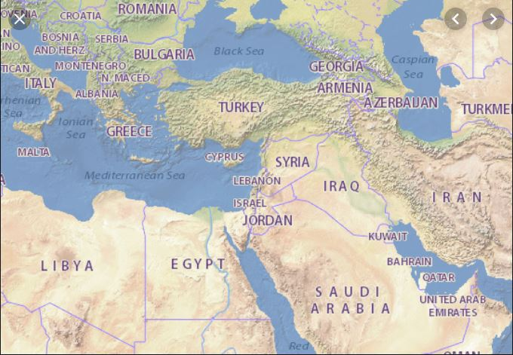

Figure : Location of Lebanon

Lebanon with its 4 million citizens has always faced difficulties from economic hardships to wars. Lebanon has a total of 100 billion dollars in debt and is classified third in the world with the ratio of its debt to its GDP at 151%. The unemployment rate was around 6% and the inflation rate around 3% (***tradingeconomic.com***). However, 2019 made things even worse. Starting October 2019, strikes and revolutions have started all around the country. In three months, it has already increased the inflation rate to 33% and increased the unemployment rate to over 25%.

These facts have led to an increase in the immigration rate from Lebanon. In 2019 alone, and up to November, it has been estimated that around 61,924 have left the country. This number is expected to double as the revolution and strikes have not settled down after over three months now.

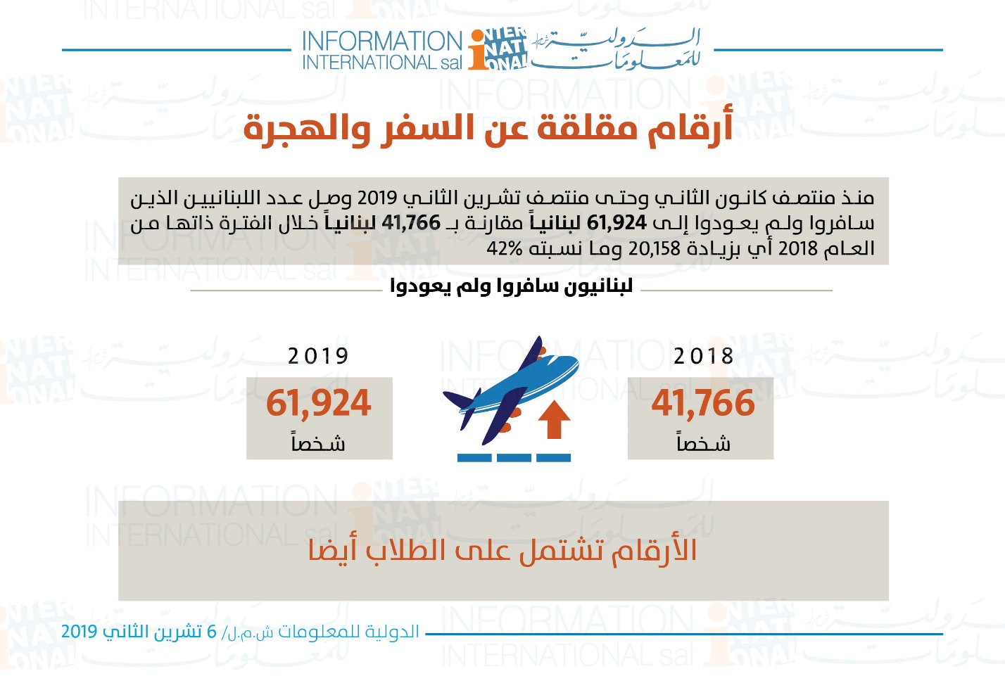

Figure : 2019 Immigration Numbers

As a Lebanese citizen, I was approached by a couple of friends looking for investment ideas to benefit from this fact and at the same time help those immigrants preserve their traditions and habits wherever they end up going.

Since Lebanon is famous for its cuisine, I suggested that the best idea is to open Lebanese restaurants in the countries/areas where these people are immigrating to attend to their huge numbers. However, in order to do that, we need to know the place where most of these Lebanese are going so that our investment will be successful since it will be visited by the maximum number of immigrants possible.

As a result of these facts and ideas, we ended up with the following problem to solve: “**Where is the best place to open a restaurant to cater for the increasing number of Lebanese immigrants?**”

In other words, we need to find the country or city where most immigrants are settling and then once we find it, we should look for the best neighborhood or area to open the restaurant in so that we make sure that a huge percentage of these immigrants will be the customers of the restaurant.

# Data

Since we are dealing with immigration, the best resource to find data is the UN. According to the excel sheet downloaded from <https://www.un.org/en/development/desa/population/migration/data/estimates2/estimates19.asp>, it shows that during 2019, Canada has received 30644 persons from Lebanon. In other words, Canada alone has received more than 49% of the Lebanese immigrants of 2019. As a result, it became obvious that the country we should focus on is Canada because Canada alone caters for half of the Lebanese immigrants which we are aiming to serve and benefit from.

After determining Canada, we need to find out what part of Canada is welcoming this huge number of Lebanese since we can’t open restaurants in every city in Canada. According to ***canadianarabinstitute.org***, the city with most Arabs is Montreal with the Lebanese being the first among Arabs.

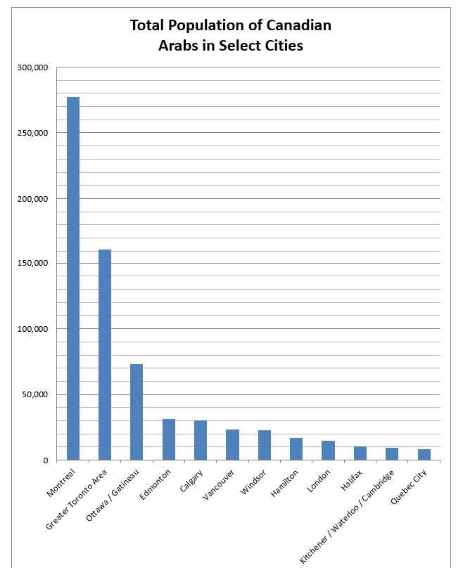

Figure : Arabs Distribution in Canada

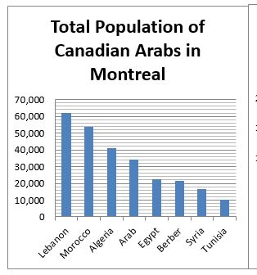

Figure : Lebanese percentage among Arabs in Montreal

So now we are sure that Montreal is the city that is welcoming the highest number of Lebanese immigrants. Now we are able to focus on Montreal since it will be the city that will host the restaurant we intend to build to cater for customers and mainly the huge number of Lebanese.

The city is determined, now we need to determine what area/neighborhood is best for opening a restaurant in Montreal so that it would be a successful investment.

In order to do so, we need to find out how many Boroughs and neighborhoods exist in Montreal so that we can analyze them and determine the favorite locations for this restaurant. I was not able to find a finalized table for Montreal’s boroughs and neighborhoods, therefore, I relied on the data listed in Wikipedia, to create my own table for Montreal.

According to <https://en.wikipedia.org/wiki/Boroughs_of_Montreal>, Montreal has 19 Boroughs.

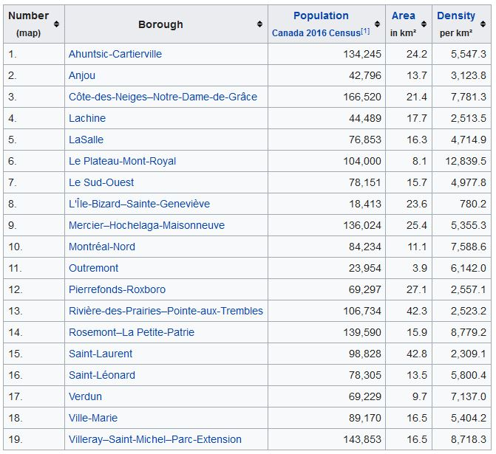

Figure : Montreal Boroughs

Then I retrieved the neighborhoods of every Borough listed above using: <https://en.wikipedia.org/wiki/List_of_neighbourhoods_in_Montreal>. I ended up with a total of 42 neighborhoods.

Having the Boroughs and Neighborhoods, I logged to <https://worldpostalcode.com/canada/quebec/montreal>, to retrieve the postcodes and latitudes and longitudes for each neighborhood as I need to use the latitudes and longitudes to utilize the foursquare location data to get a list of available venues in each neighborhood so that I can have an idea of the list of attractions in each neighborhood.

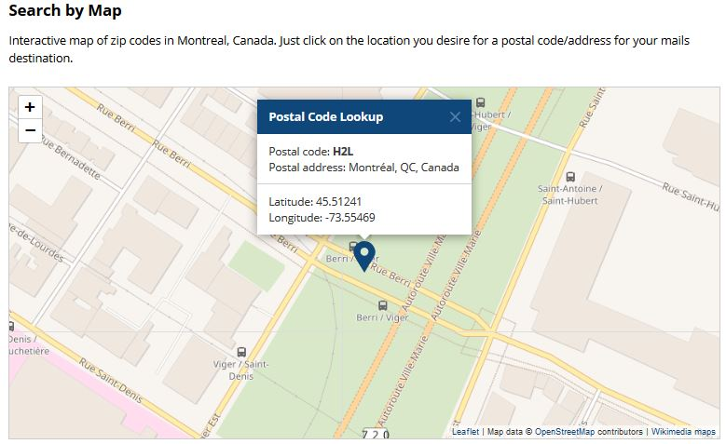

Figure : Getting Longitude and Latitude of Neighborhoods

Once I collected the postcode, Borough, Neighborhood, Longitude and Latitude, I merged the data in a csv file called Montreal Neighborhoods. This file contains 5 columns and 42 rows. This csv file will be imported and read in a Jupyter Notebook to analyze the data and supply the latitude and longitude for each neighborhood for the foursquare algorithm to determine the venues which will allow us to specify the best location to open the Lebanese restaurant.

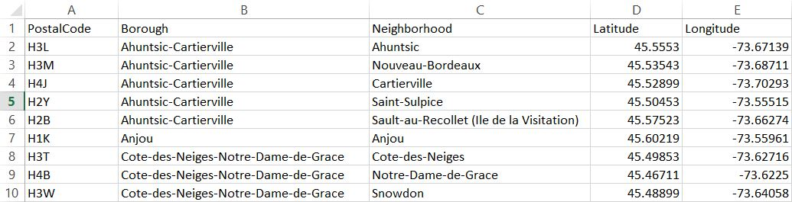

Figure : Part of the CSV file